
Electricity is a form of energy where the energy supply comes from rapidly moving electrons. You may remember from year 8 that there are two main forms of electrical energy;
- Static electricity
- Current electricity
Try this exercise to reacquaint you with static electricity
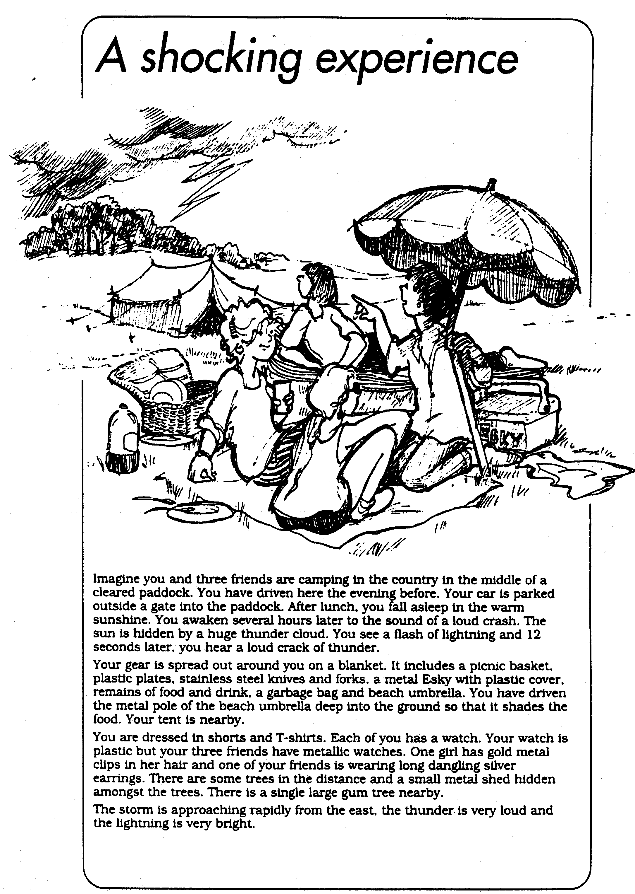
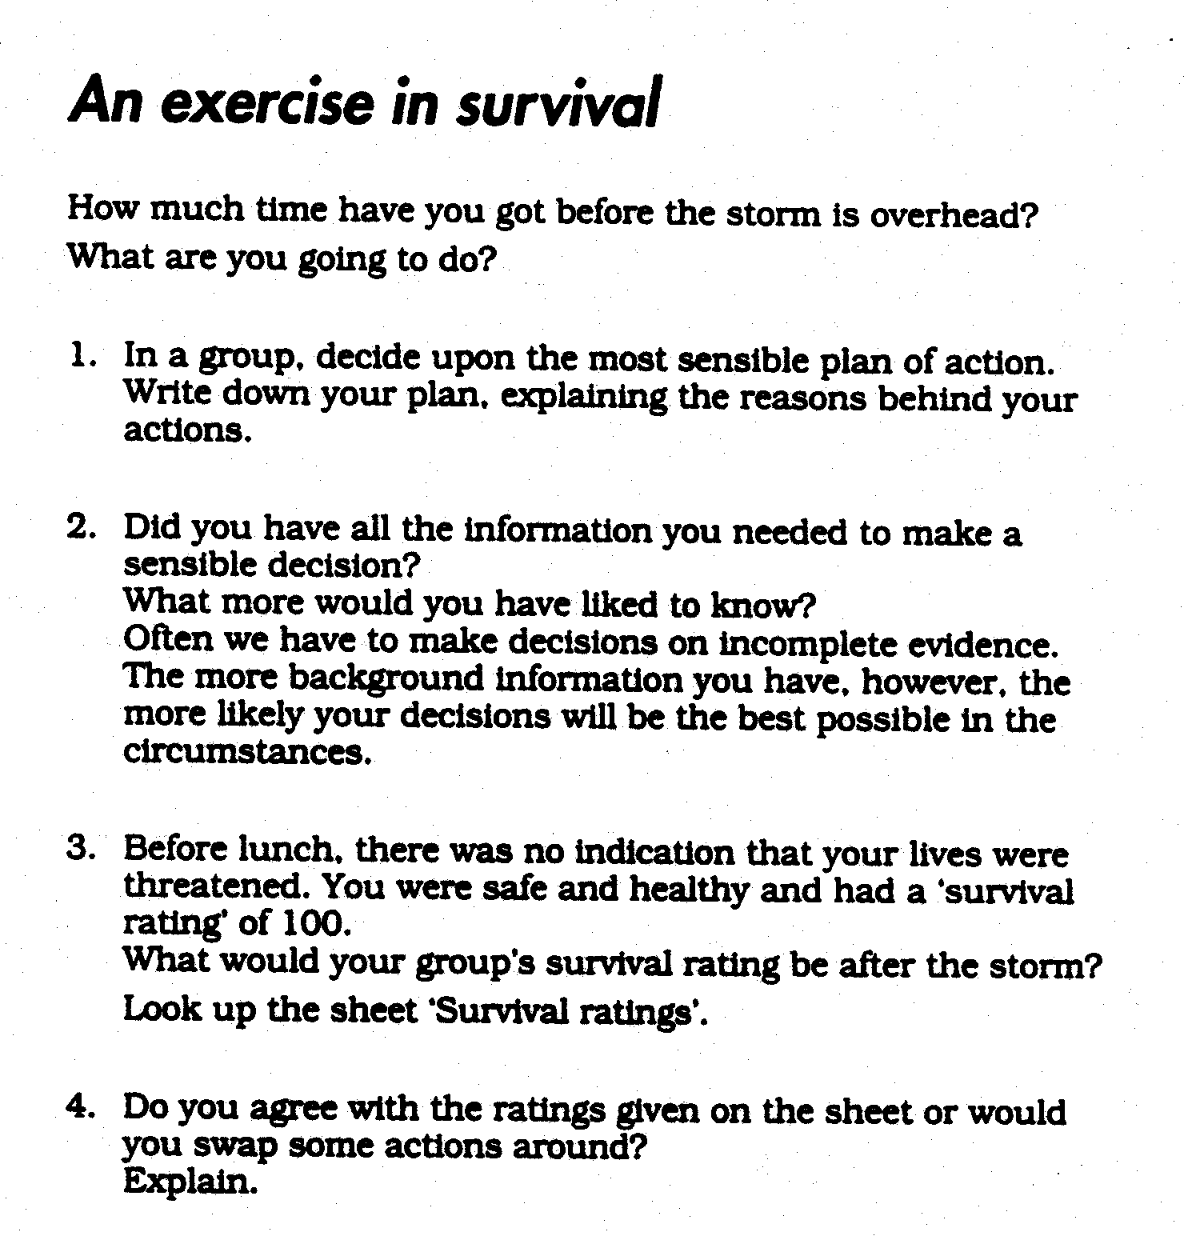

- STATIC ELECTRICITY:

SOURCES OF ELECTRICAL ENERGY

A convenient source of electrical energy in the laboratory is the cell. The electrons the cell releases come from chemical reactions that occur within it. That is, cells are electron sources, and they can 'pump' electrons around an electrical circuit.

A battery is made up of two or more cells linked together.

2. CIRCUITS

a) Simple Circuits

A circuit is a completed loop of conducting material joining the terminals of a cell or a battery.

In the drawing of circuits, the following symbols are used:

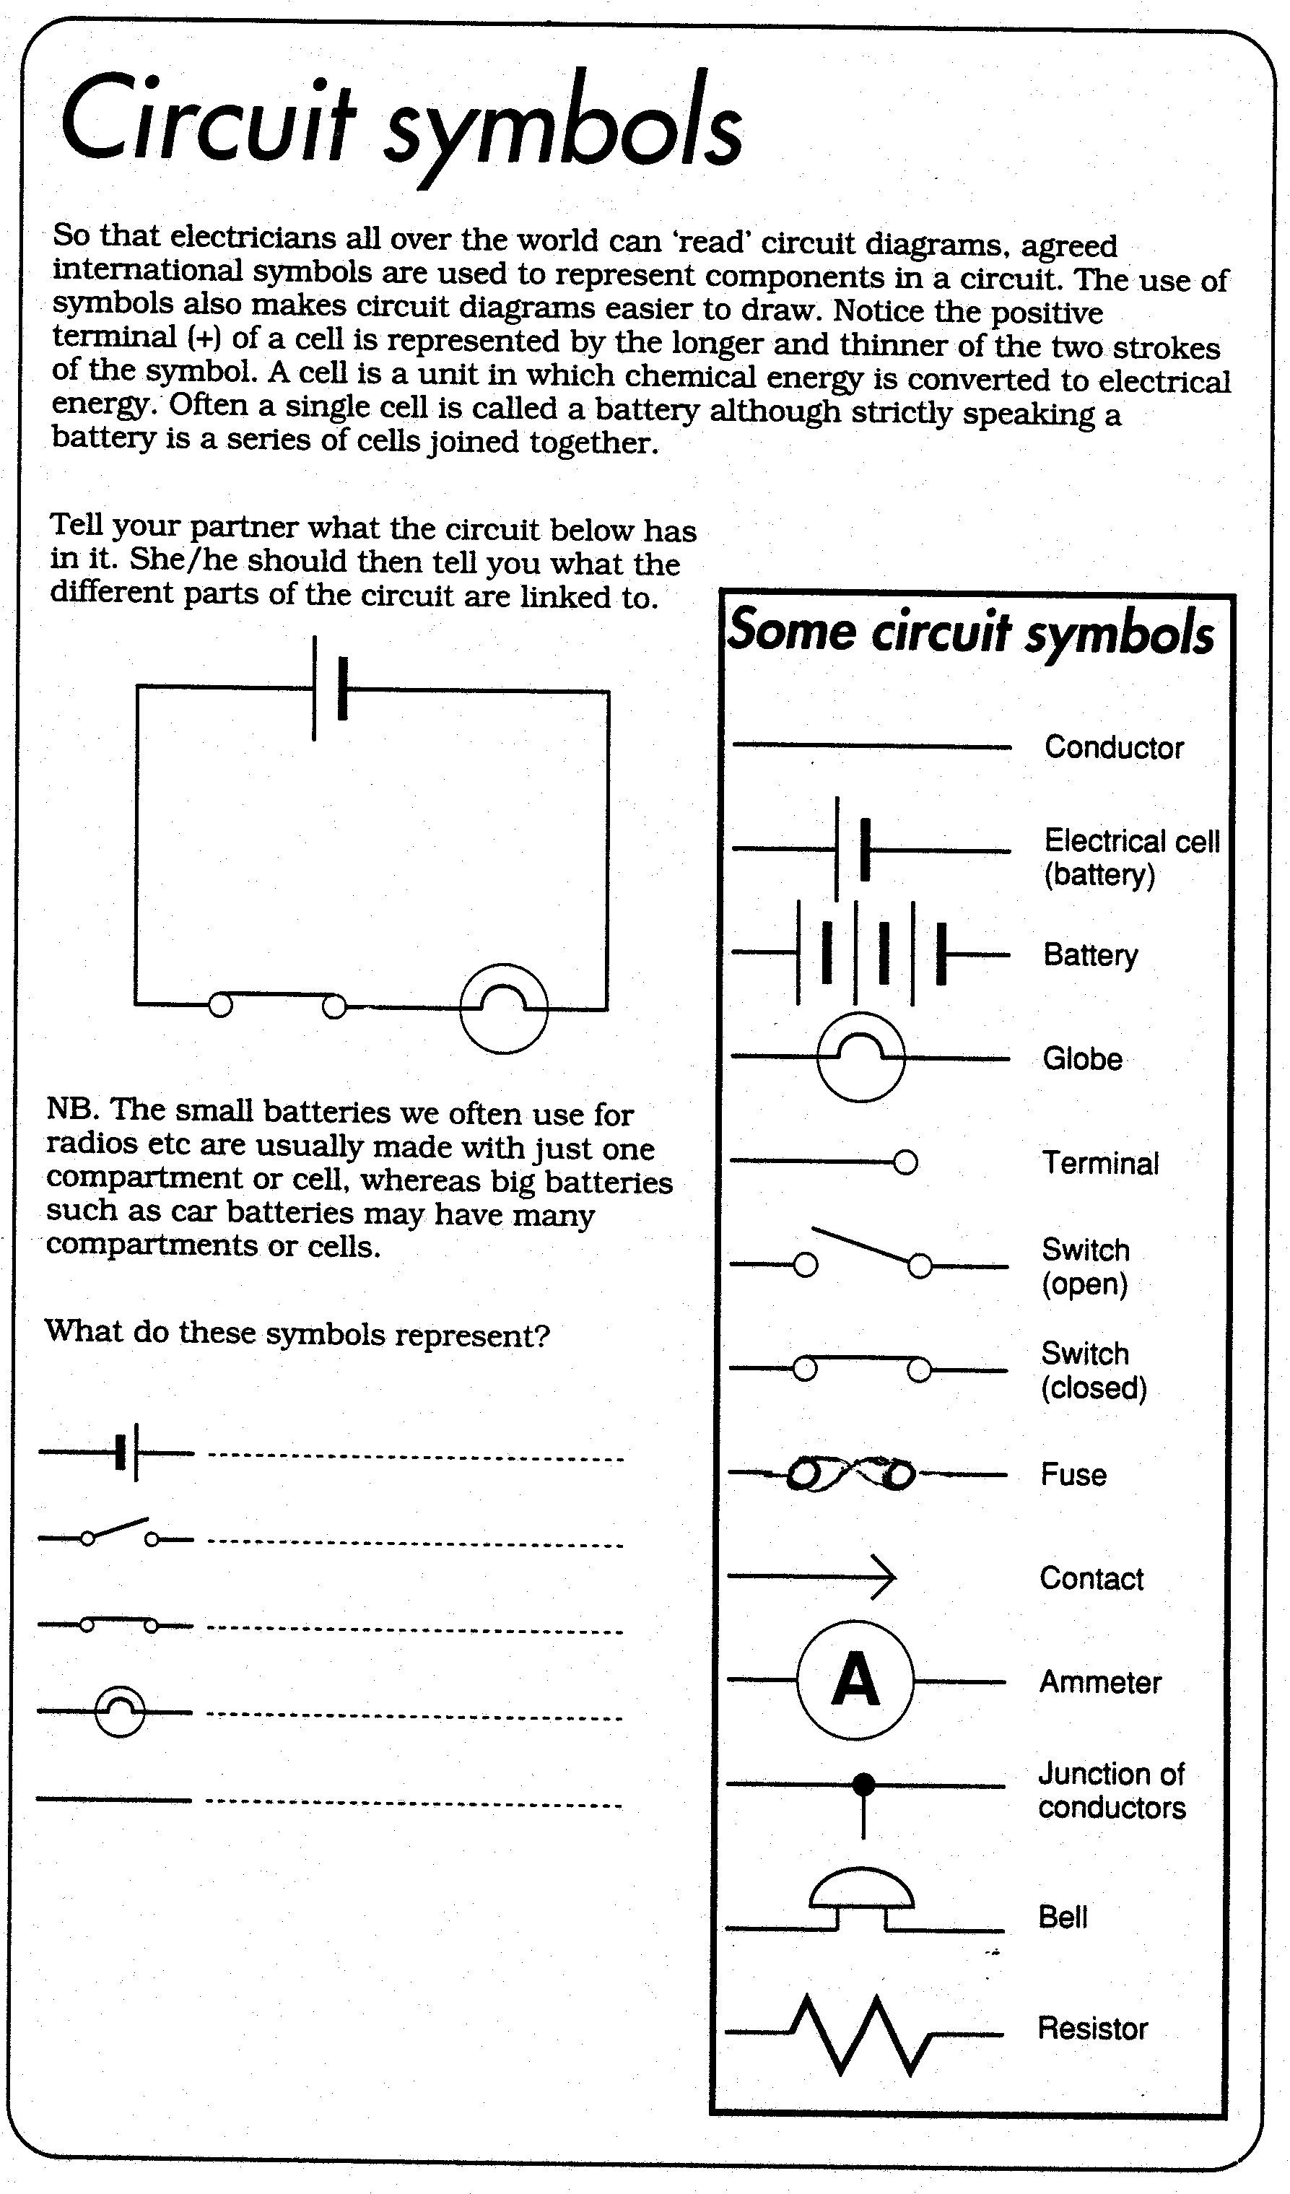

A circuit is drawn using straight ruled lines and in a rectangular shape even though in reality it may look quite different.

Draw examples of circuits in the space below.

- a cell, a switch, a globe ,an ammeter, a resistor joined by conducting wires.

ii) 2 cells, 2 globes, a bell and a resistor joined by conducting wires

b) Electric Current

An electric current is a flow of charged particles, pumped by a cell, around a circuit. In metals, the electric current is a flow of electrons. For a current to flow, the circuit must be complete.

The size of current flowing around a circuit can be determined by examining the brightness of a globe in the circuit (the brighter the globe, the greater the current).

A switch is a device for breaking a circuit. I can be drawn open or closed.

Questions

1. In which of the following will an electric current flow?

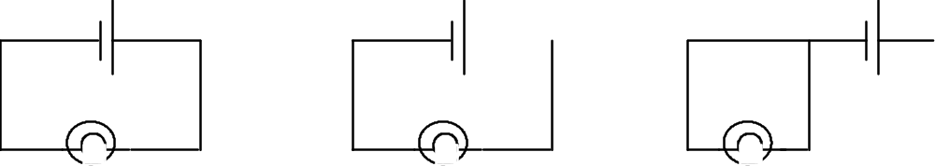

2. Consider the following circuit:

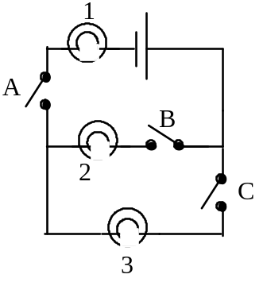
Which globes will glow when the following switches are on?

i) Switch A
ii) Switch A and Switch C
iii) Switch B and Switch C
iv) Switch A and Switch B

3. Now you draw a circuit in which there are 3 globes and 2 switches and 2 cells. When 1 switch is closed only 1 globe glows and when the other switch is closed the 2 other globes glow.

ACTIVITY 1: Simple Circuits

Materials: 1 electricity kit
Examine all the components of the kit carefully and make sure you understand what each is.

Method:
1. Build each of the following circuits and determine whether the globe is off, dim or bright.

Draw each of the circuits and write your answer under each circuit diagram..
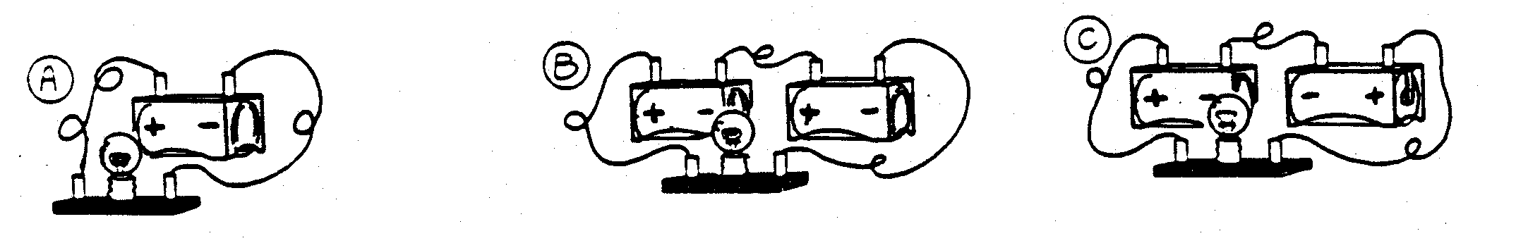

2. Using 2 cells, 1 switch, 2 globes and conducting wires, build as many different circuits as you can, in which the light globes glows when the switch is on.

Draw each of these circuits in the space below..

3. Complete the tables by either connecting Put a √ for lamp ON
up each circuit, or by "tracing" the electron and a X for lamp OFF
flow around the circuit.

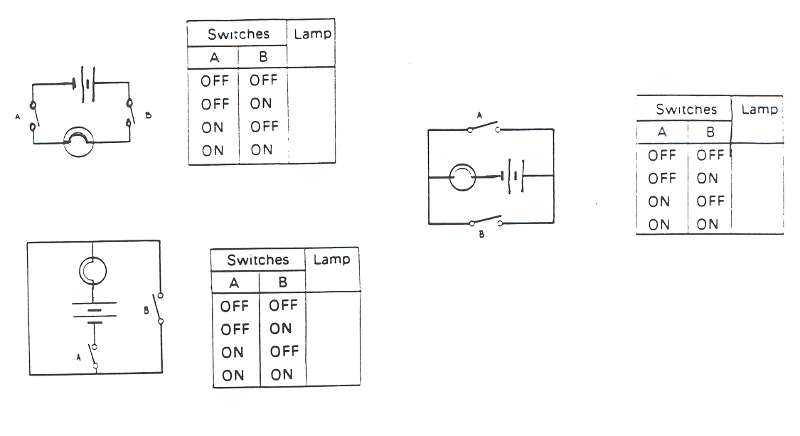

PROBLEM SHEET 1 – Simple Circuits

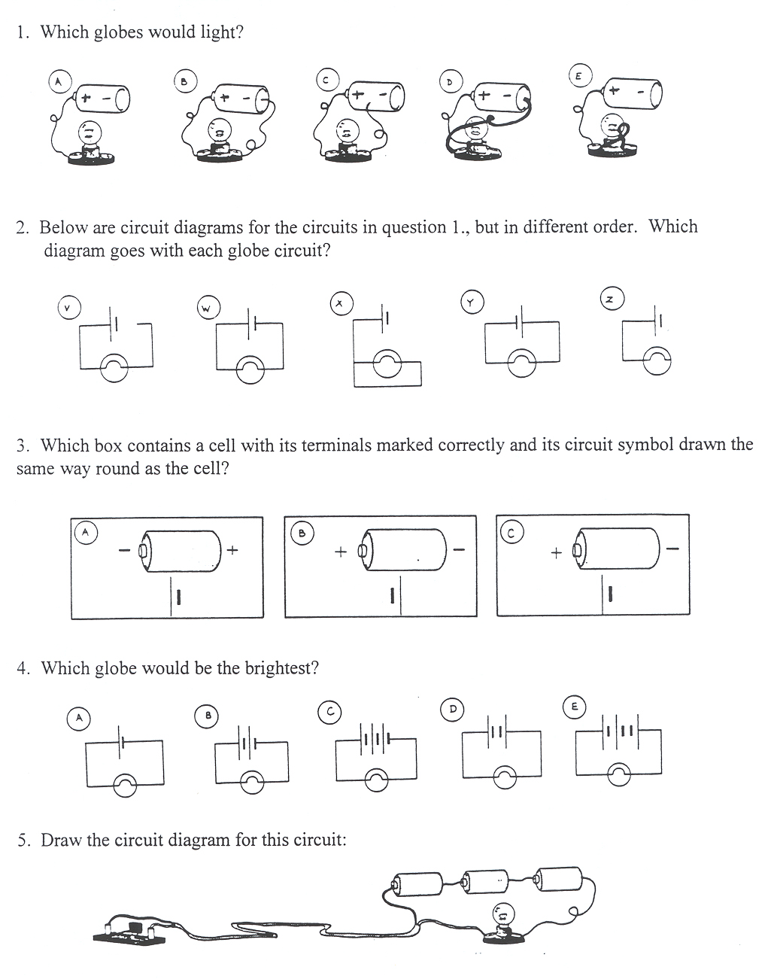
- Complete the tables for the switches in the following circuits:

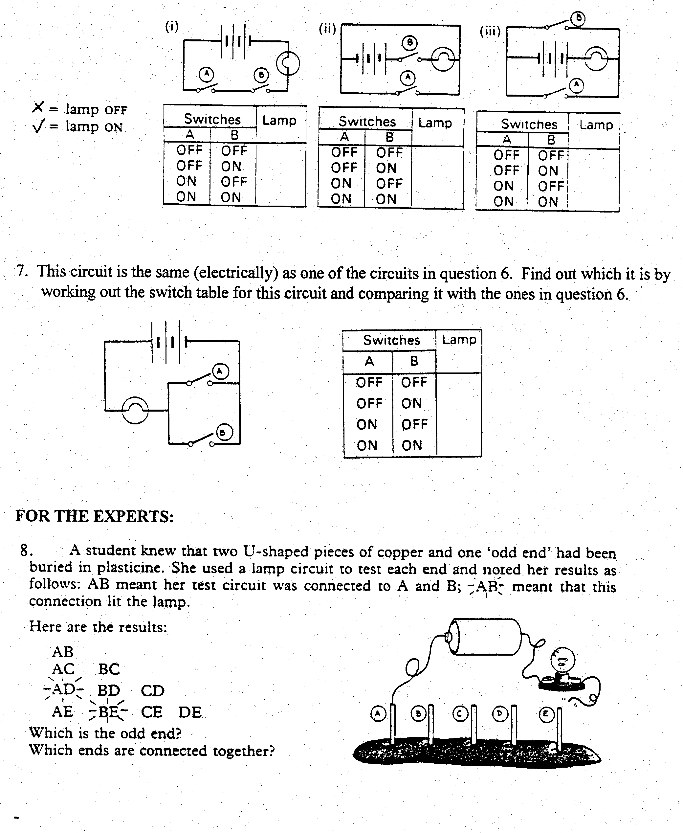
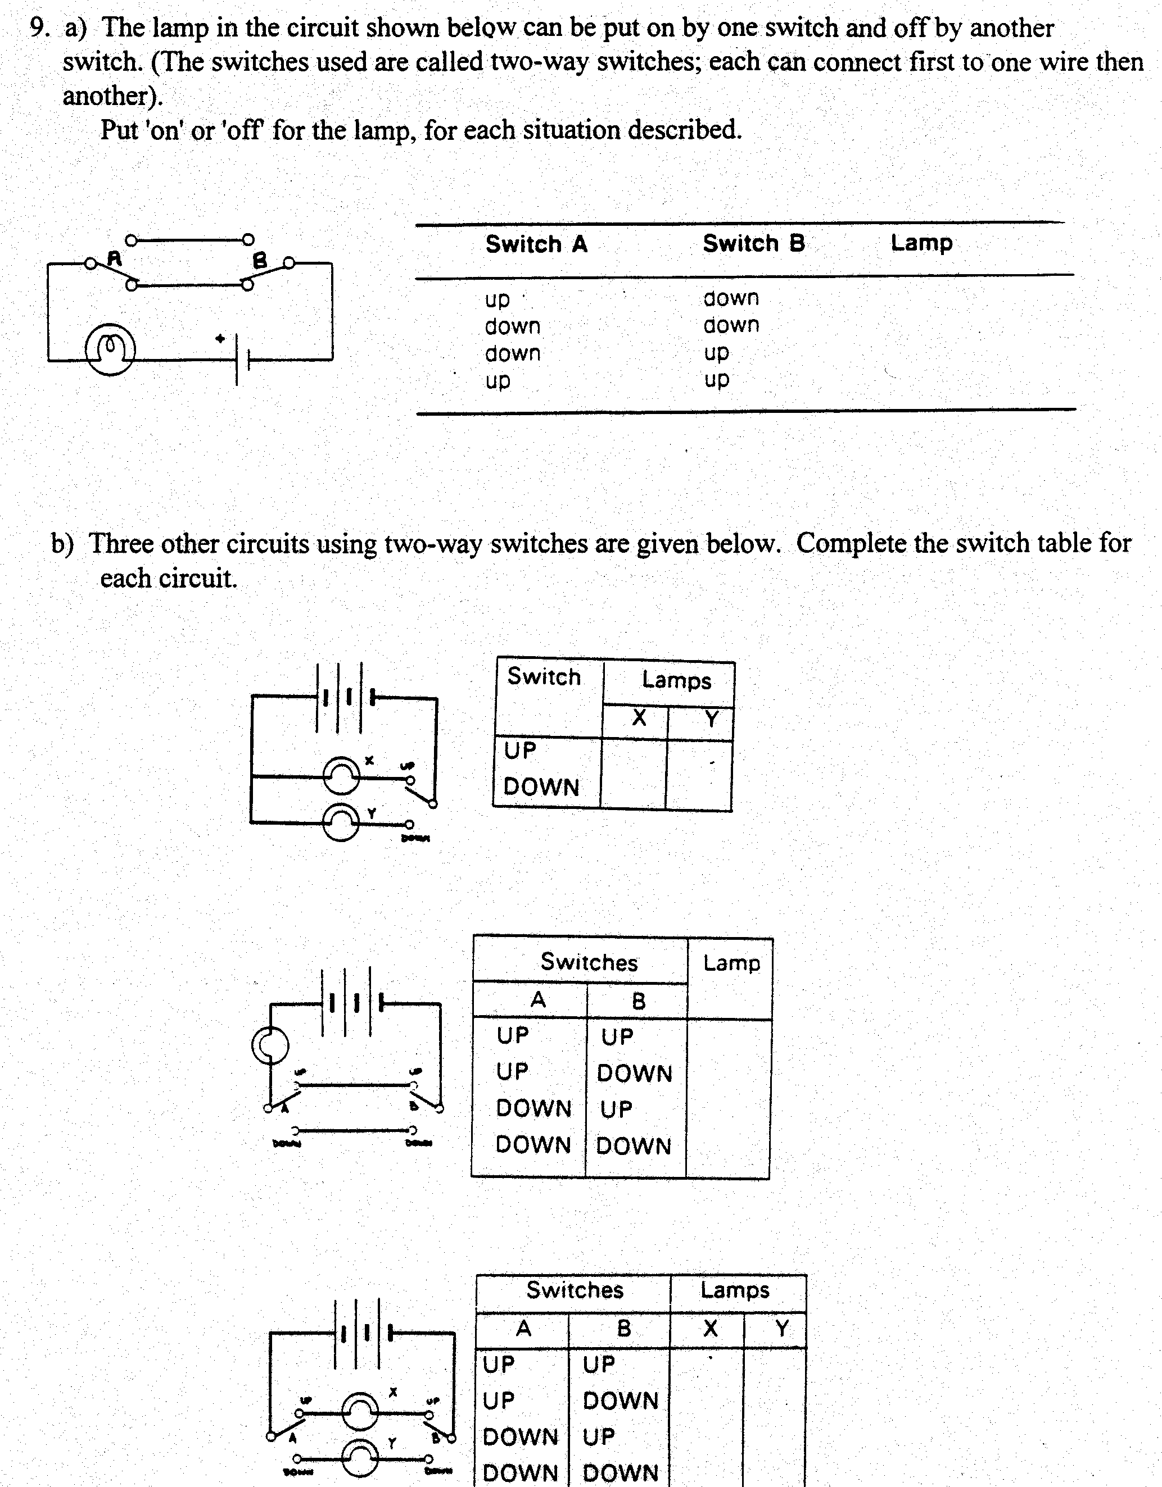
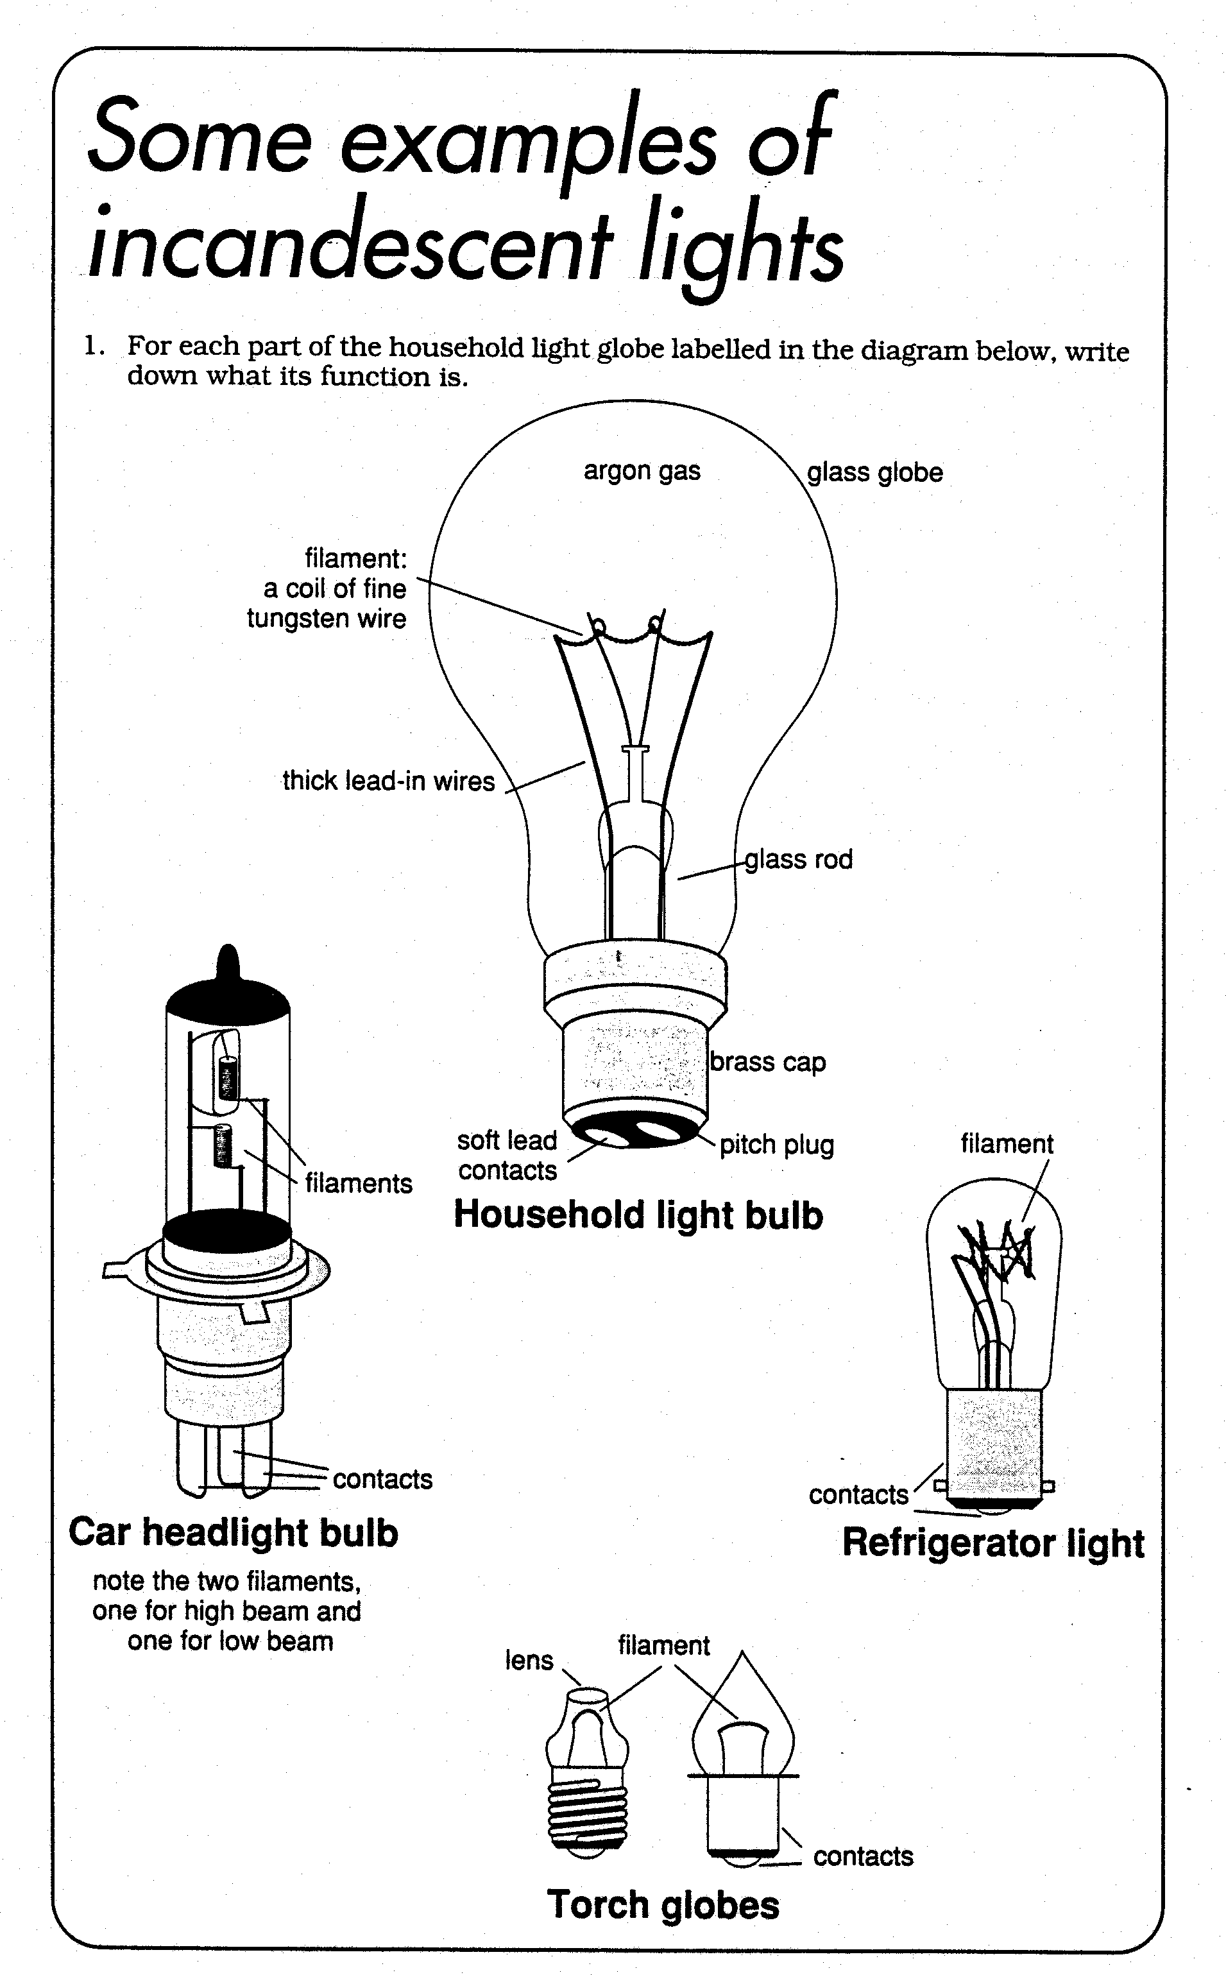
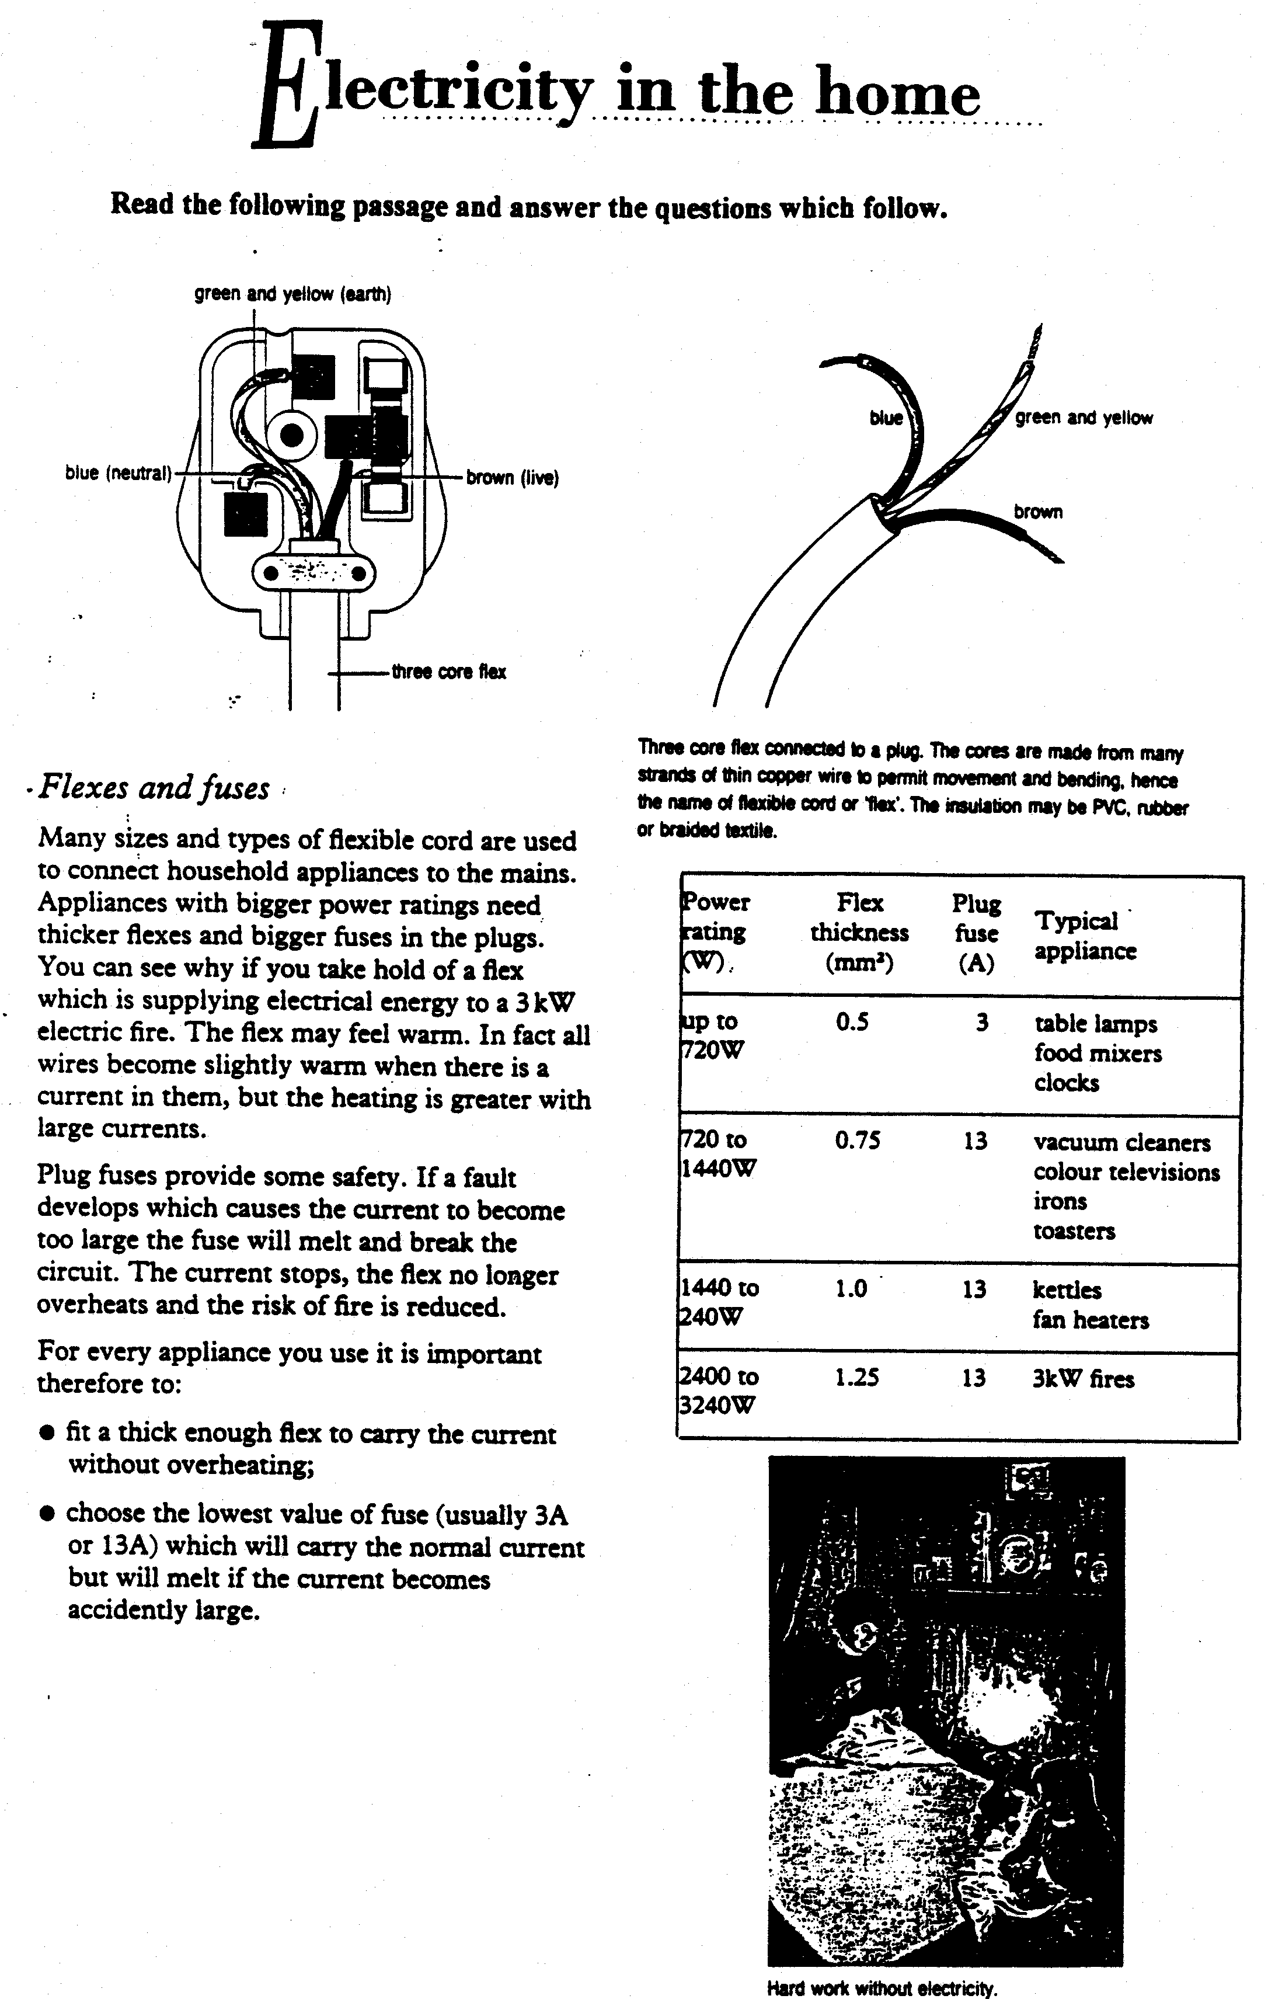
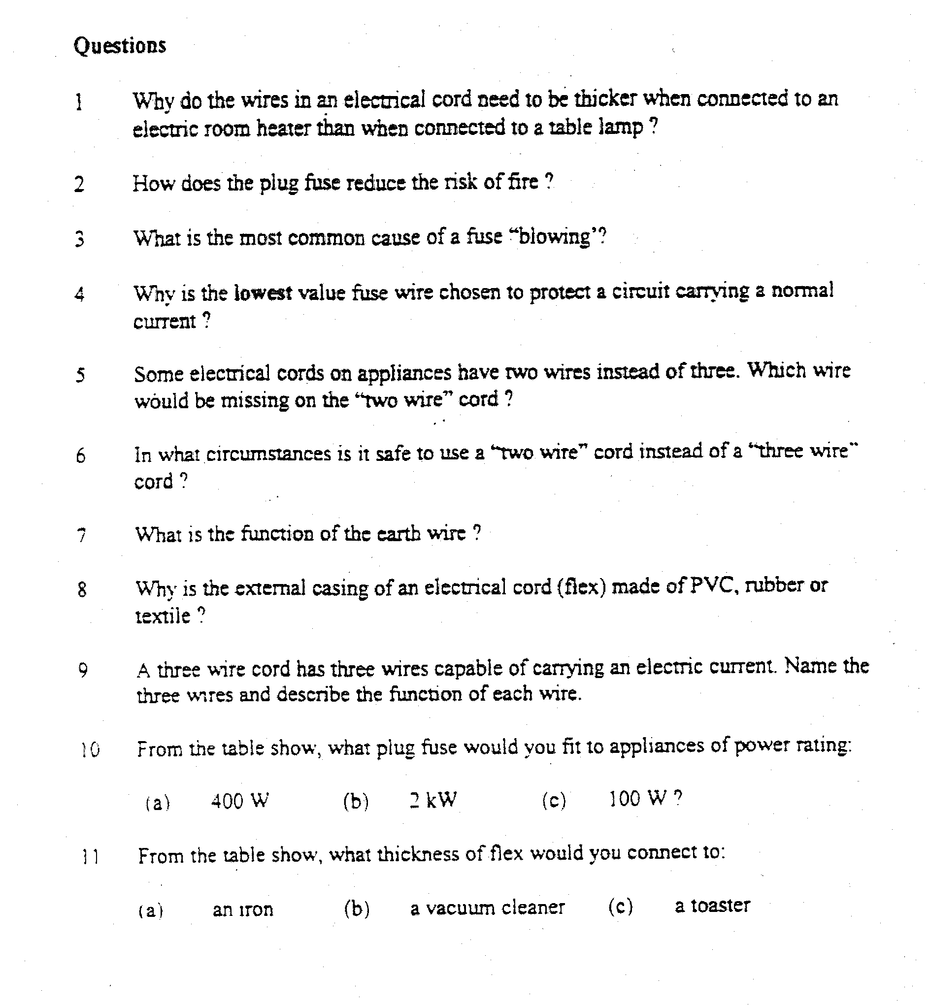
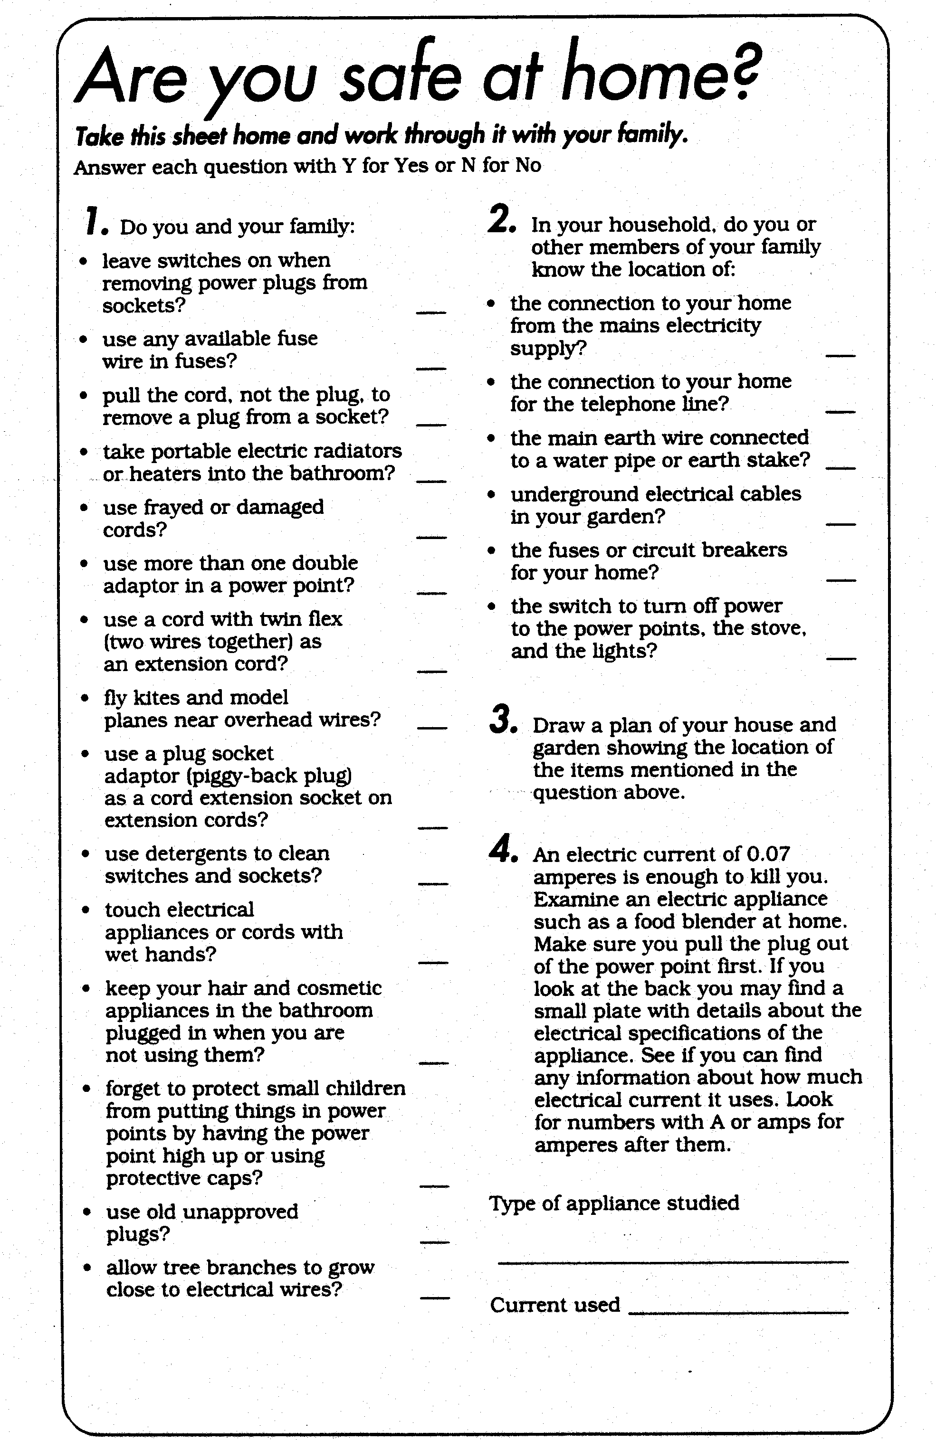

3. RESISTANCE

Resistance in a circuit is any device that restricts or inhibits the current through it.

- If a device e.g. a piece of wire, has a high resistance then the flow of electricity through it is
greatly reduced.

- If a device has a low resistance then the flow of electricity through it will be only slightly reduced.

- The greater the resistance of a device, the smaller the current that will flow through the circuit.

- When an electric current flows through resistance in a circuit, some of the electrical energy is
transformed to heat energy i.e. heat is produced when electricity flows through resistance.

- The greater the resistance, the greater the amount of heat produced.

- Different conductors can have different resistance properties.

For example, copper has a low resistance but nichrome and tungsten have high resistance.

Light globes contain a piece of high resistance wire, which produces much heat (and thus light) when an electric current is passed through it. Thus, a light globe can be regarded as a device with high resistance.

Example
1. Which of the following circuits has the greater resistance?

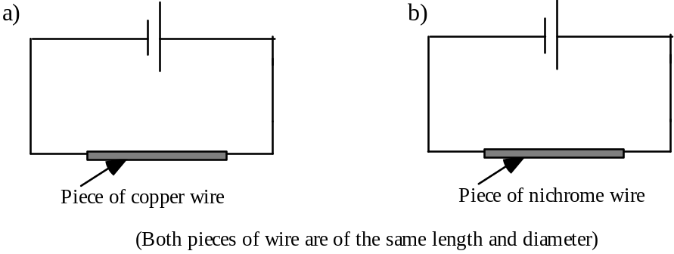

2. Which of the following circuits has the lower resistance?

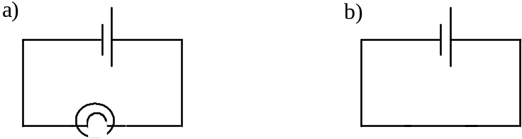

ACTIVITY 2: Resistance

Method:
1. Set up the following circuit
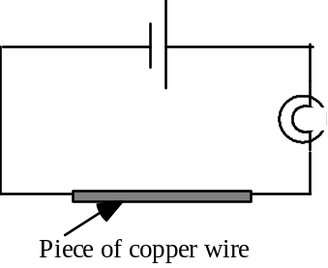

1. How bright is the globe ? ______________________________________________________

2. Replace the copper wire with a piece of nichrome wire (of the same length as the copper wire). How bright is the globe now ? ___________________________________________

3. Compare the brightness of the globe with that obtained for the copper wire.

_______________________________________________________________________________

4. Which wire has the greater resistance, copper wire or nichrome wire? ______________________

5. Now replace the nichrome wire with a small piece of 'steel wool' wire. Describe what happens to the globe now.
___________________________________________________________

6. Explain what happened with the ‘steel wool wire’ . ____________________________________

________________________________________________________________________________

7. Electrical energy is more easily transformed to heat energy using ______________ resistance wire.

Application of Resistance

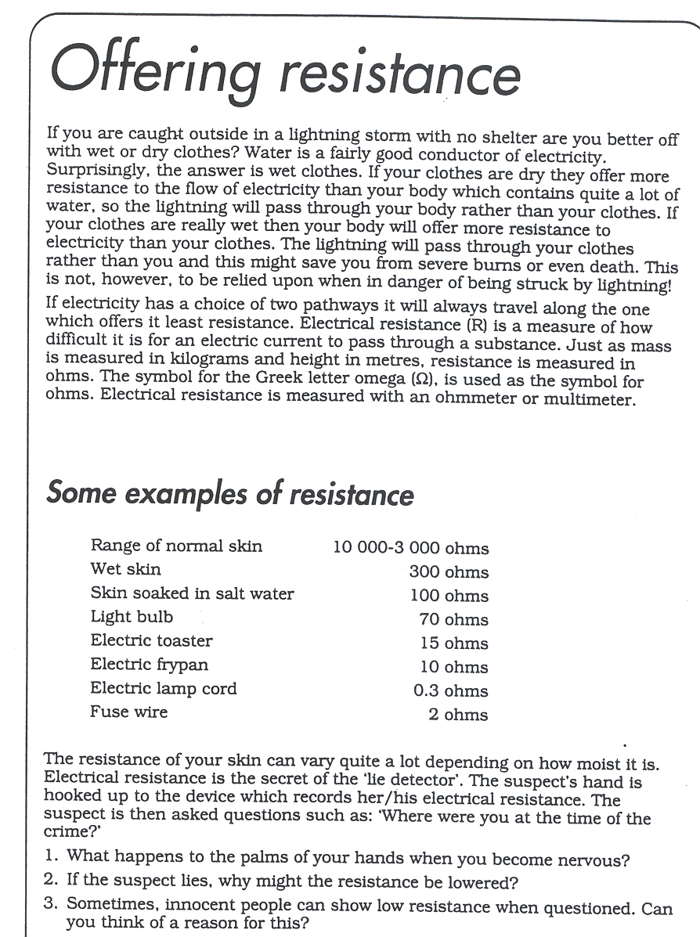

4. SHORT CIRCUITS

A 'short circuit' is an alternative conducting pathway of lower resistance, which by-passes a particular resistance, globe or other appliance in a circuit. It is not necessarily the shortest path however.

E.g. in the following circuit, the light globe will not light up because of the 'short circuit' between points A and B (i.e. it is 'easier' for the electrons to travel through wire AB rather than through the light globe.)
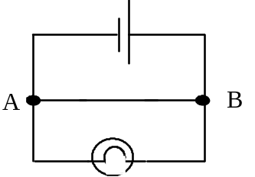

ACTIVITY 3: Short Circuits

Method:
1. Set up the following circuit

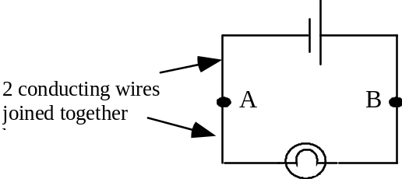

2. Sides A and B are made of two wires each, joined together by twisting the ends

3. Place another conducting wire between A and B. This is the short circuit.

4. Predict what you think will happen. ________________________________________________

Test your prediction.

5. What happens to the globe when the wire between A and B is connected ?

______________________________________________________________________________

6. Explain what happened to the globe. ______________________________________________

________________________________________________________________________________

5. FUSES

Fuse wire is a relatively high resistance conductor with a low melting point.

A fuse wire will melt if too large a current is passed through it. When it melts the circuit is broken and current can no longer flow.

A fuse is a protective or safety device, included in a circuit, which melts when a short-circuit or overload
results in too high a current passing through the circuit.

In circuit diagrams, a fuse has the symbol

Example

In which of the following circuits would you expect the fuse to blow if a wire was placed between A and B?
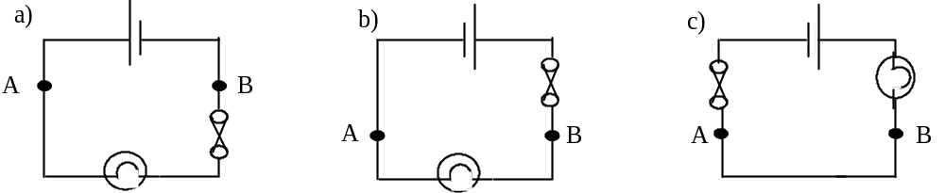
ACTIVITY 4: Fuses

Method:
1. Connect up the following circuit using a strand of steel wool as the fuse wire. Twist the steel wool repeatedly to make the steel wool wire. Press the switch on.

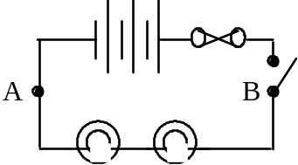

2. Do the globes glow? _____________________________________________________

3. Where would you place a wire to create a short circuit ? Press the switch on, then short circuit the globe circuit.

What happens this time ? ______________________________________

4. Explain why this happens. _______________________________________________________

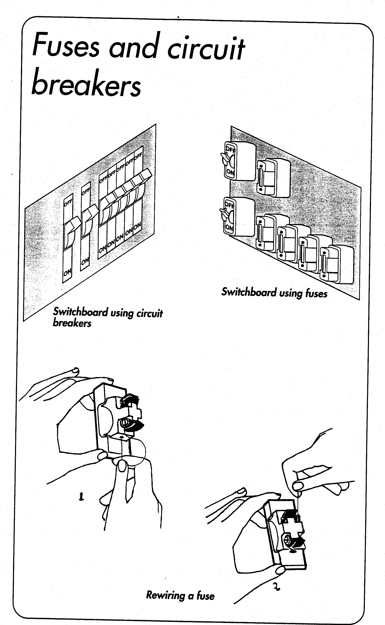

Read this passage and answer the questions on the following page.
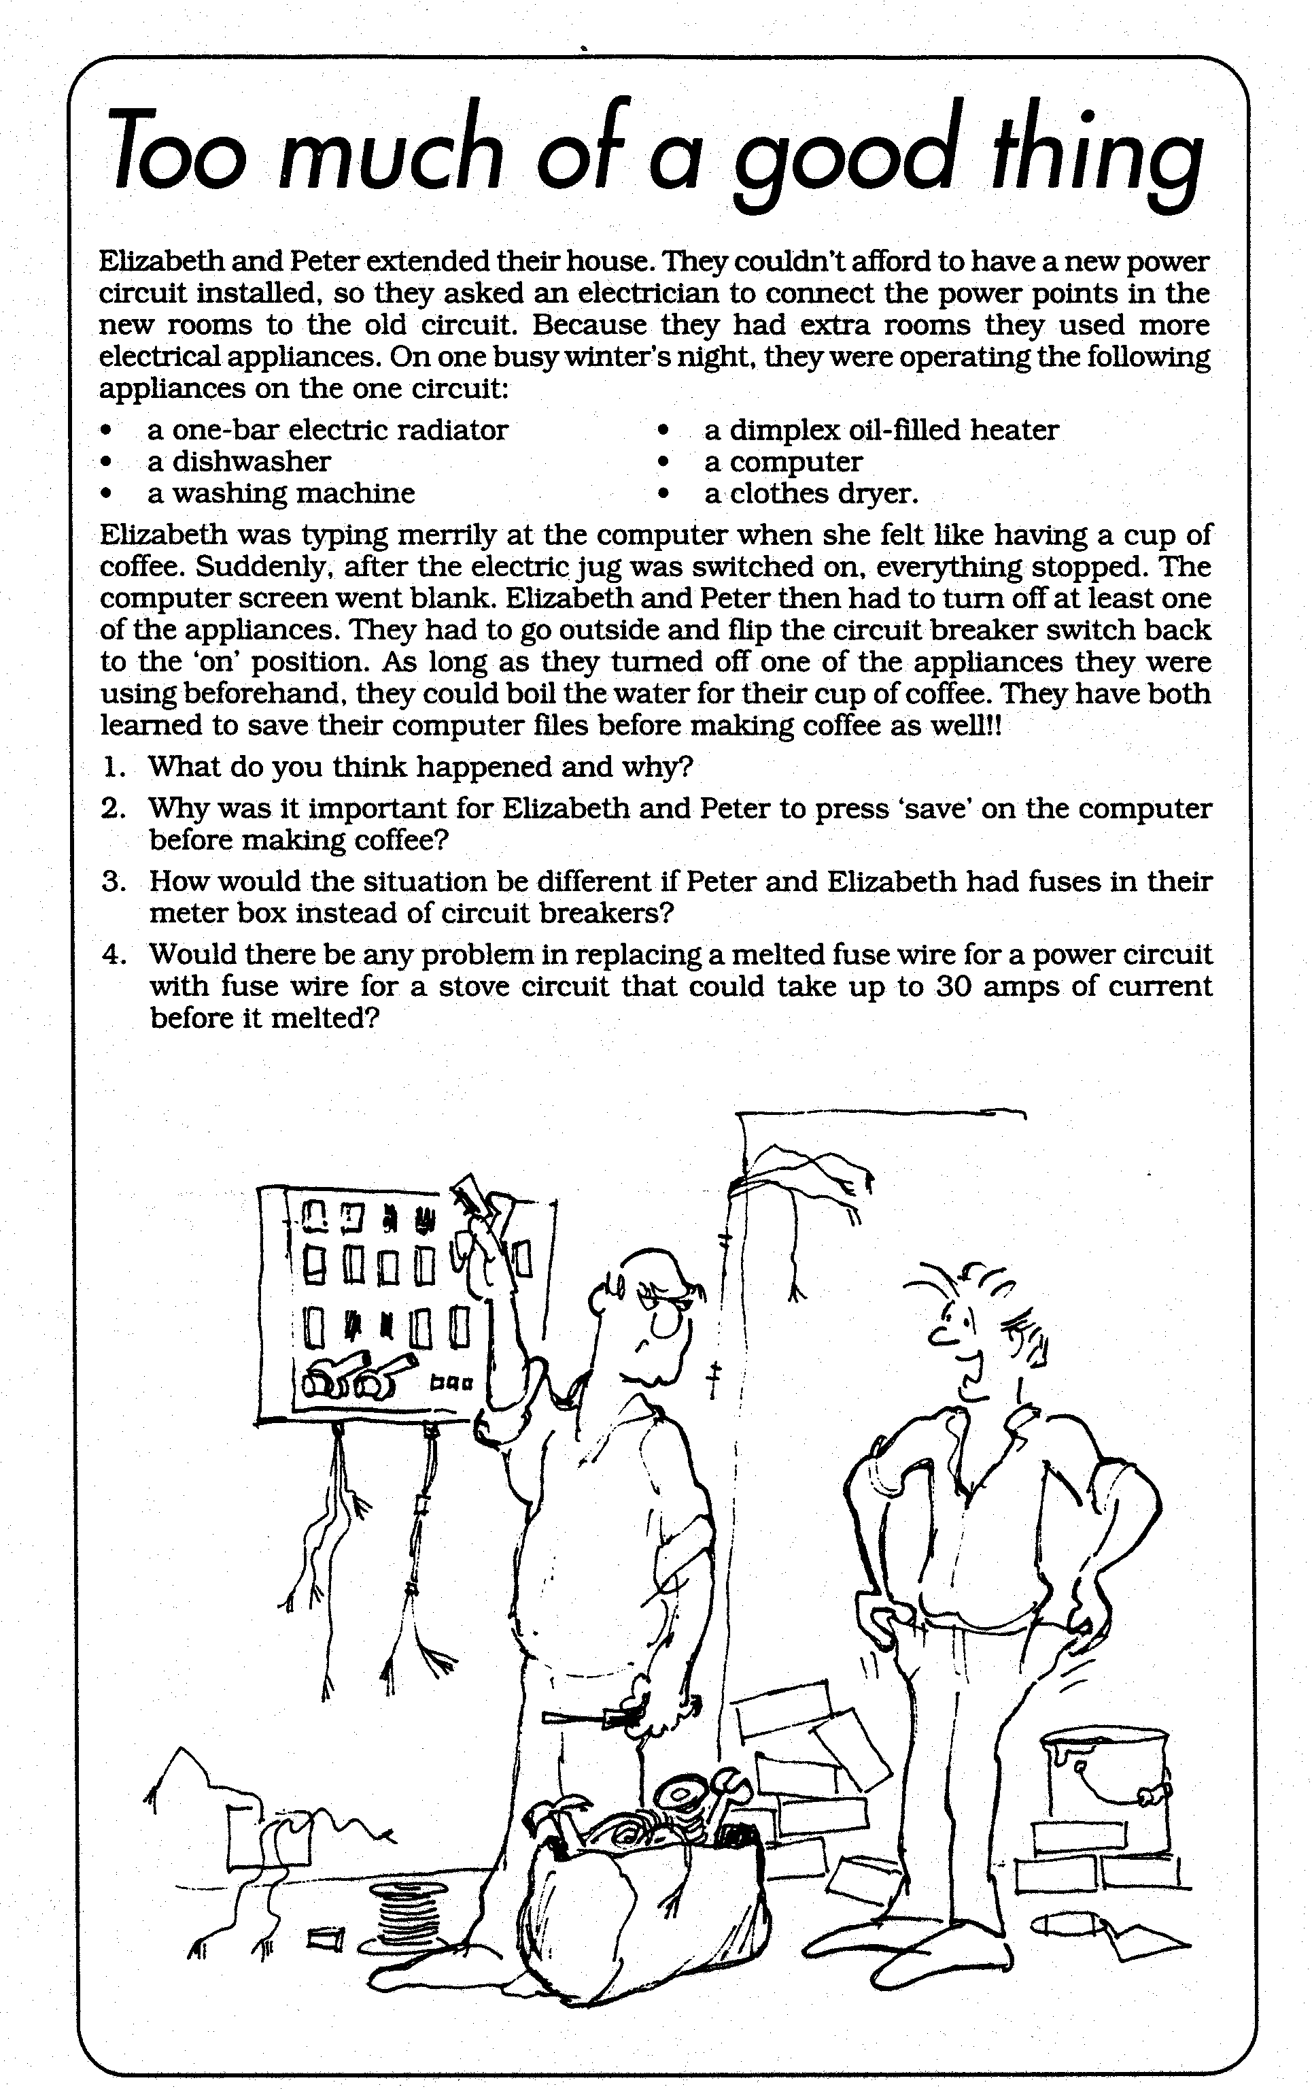

- _______________________________________________________________________

__________________________________________________________________________

- _______________________________________________________________________

__________________________________________________________________________

- ________________________________________________________________________

__________________________________________________________________________

- ________________________________________________________________________

__________________________________________________________________________

PROBLEM SHEET 2 - Resistance, Short Circuits and Fuses.

1. Identify the following statements as true or false
a) An electric current can flow more easily through a wire of high resistance than through a wire of low resistance.
b) Wire with high resistance restricts the flow of electricity through it.
c) If a wire has a low resistance, it will probably heat up considerably when a current is passed through it.
d) A 'short circuit' is a circuit which is very small.
e) A 'short circuit' can occur if in a particular circuit an alternative pathway of low resistance is produced.
f) Fuse wire is made from wire which has low resistance and low melting point.
g) Fuse wire is made from wire which has high resistance and high melting point.
h) Nichrome wire has a higher resistance than copper wire.
i) The wire used to make the filament in a light globe has high resistance and low melting point.

2. Explain why the globe in the following circuit will go out when a wire is placed between
points X and Y.
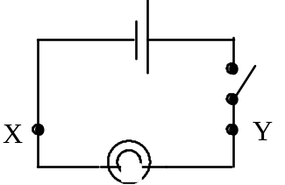
_________________________________________________________________________

__________________________________________________________________________

3. Which of the following circuits will be 'short circuited' (i.e. the globe will stop glowing) when a wire is placed between points A and B?

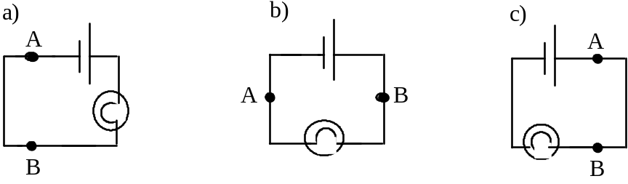

4. For the following circuit, which globe/s will go out when a wire is placed between X and Y?

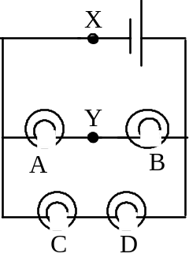

6. SERIES CIRCUITS

a) A series circuit is one, which contains only one possible pathway through which the current can flow.

Example
Draw a circuit diagram in the space below in which the two cells are in series and the two globes are in series

b) When two globes are in series in a circuit, if one globe is removed, the other will not light.

c) Two globes in series will not glow as brightly as just one globe i.e. the globe in circuit A will glow brighter than the two globes in circuit B (assuming the other parts of the circuits are the same).

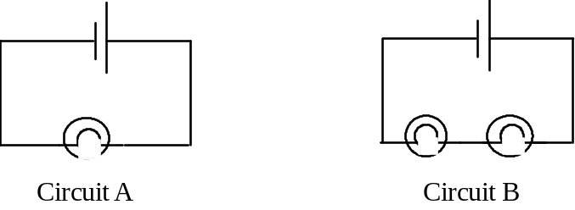

Example
Suggest reasons why the globes in Circuit B will be dimmer:
__________________________________________________________________________

__________________________________________________________________________

d) Two cells in series will provide twice the electron 'pumping' energy (or voltage) of one cell. For example, the globe in circuit C will glow brighter than the globe in Circuit D.

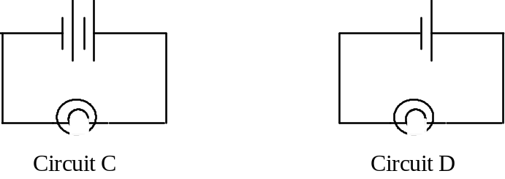

Example
Suggest reasons why the globe in Circuit C will be brighter:
__________________________________________________________________________

ACTIVITY 5: Series Circuits

Method:
1. Construct the following circuits and record the relative brightness of the globes on the diagram.

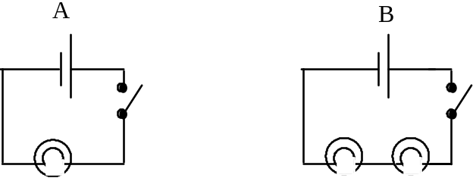

Brightness ? _______________ _________________

2. Using the globe brightness as a guide in which circuit was the larger current flowing?

______________________________________________________________________

3. Which circuit had the greater resistance? __________________________________

4. Describe the components in the two circuits and the way in which they are connected in words in the space below:

Circuit A contains __________________________________________________________

Connected in _________________________

Circuit B contains __________________________________________________________

Connected in _________________________

5. Construct circuit B again. Push the switch on, and then remove one of the globes from its socket. What happens to the remaining globe?

_______________________________________________________________________

6. Explain why this happens to the other globe. __________________________________

__________________________________________________________________________

7. Construct the following circuits and note the relative brightness of the globes in each

Circuit C - contains 1 cell, a switch and 2 globes in series

Circuit D - contains 2 cells in series, a switch and 2 globes in series

8. Draw a circuit diagram for each of the circuits and underneath each record the relative brightness of the globes

Circuit C Circuit D

7. PARALLEL CIRCUITS

a) A parallel circuit is a circuit with more than one pathway through which the current can flow.

Example
Draw a circuit diagram in the space below in which the two cells are in parallel and the two globes are in series.

b) When two globes are in parallel, if one globe is removed, the other globe continues to glow.

Explain why this happens to the other globe. _____________________________________

__________________________________________________________________________

c) Two globes in parallel will glow as brightly as just one globe i.e. the globes in circuit E will glow as brightly as the globe in circuit F. For a given cell, two globes in parallel provide less resistance and a so a greater current flow than two globes in series.

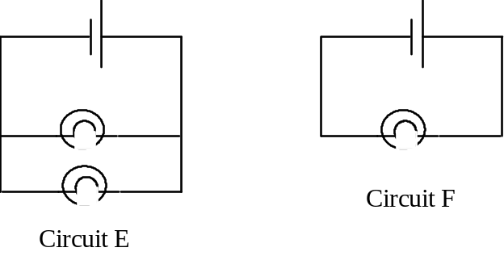

Explain why this happens ____________________________________________________

__________________________________________________________________________

Example

Examine each of these circuit diagrams then answer the following questions.

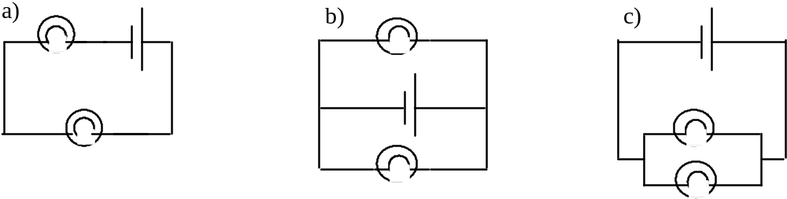

1. In which of the following circuits are the globes in series, and in which are the globes in
parallel?
__________________________________________________________________________

2. In which of the circuits will the globes glow the brightest and in which will they glow the dullest?

(Assume all cells and globes are identical) __________________________________________________________________________

3. If in each circuit, one globe blows, will the second globe continue to glow? _________________

________________________________________________________________________________

ACTIVITY 6: Parallel Circuits

Method:
1. Construct Circuit E, then Circuit F and compare the brightness of the globes in each.

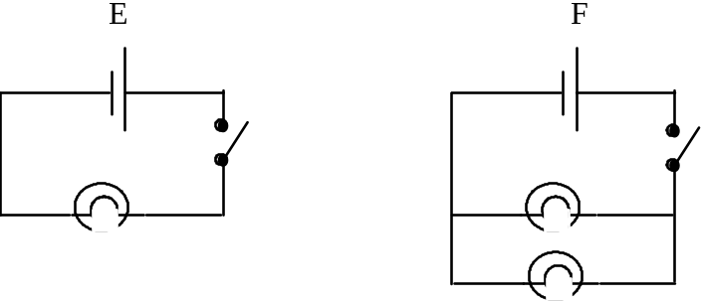

Brightness of globes ____________________ ________________________

2. Describe the components of each of the circuits and the way they are connected in words

Circuit E contains _________________________________________________________________

Circuit F contains _________________________________________________________________

3. Construct Circuit F again . Press the switch on, then remove one of the globes from its socket.

What happens to the other globe? _____________________________________________________

Explain your observation. ___________________________________________________________

4. Construct Circuit B and Circuit F again, draw them below and then compare the brightness of the globes in each. Record your observations under each circuit diagram below..

Circuit B Circuit F

5. Complete the following:
For a given cell, 2 globes in parallel provide ............................... resistance and glow ................................... than 2 globes in series.

Challenging Connections:

6. Choose from one cell, a switch and three globes to construct a circuit in which the globe/s will be more dimly light than in any other possible circuit. Draw this circuit below.

7. Choose from two cells, a switch and two globes to construct two circuits in which the globe/s will glow the brightest compared to any other possible circuit. Draw the two circuits below.

CIRCUIT 1 CIRCUIT 2

8. From one cell, a switch and three globes construct a circuit in which one globe will glow brighter than the other two globes. Draw the circuit in the space below.

PROBLEM SHEET 3 - Series and Parallel Circuits.

1. Which of the following circuits show the globes connected in series?

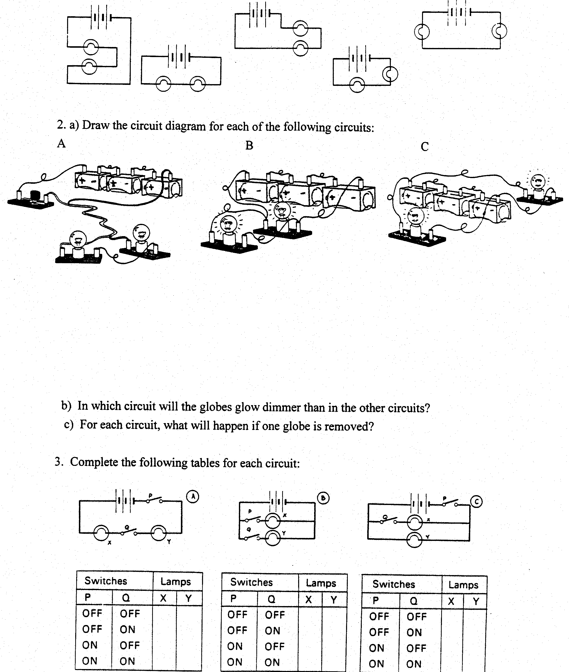
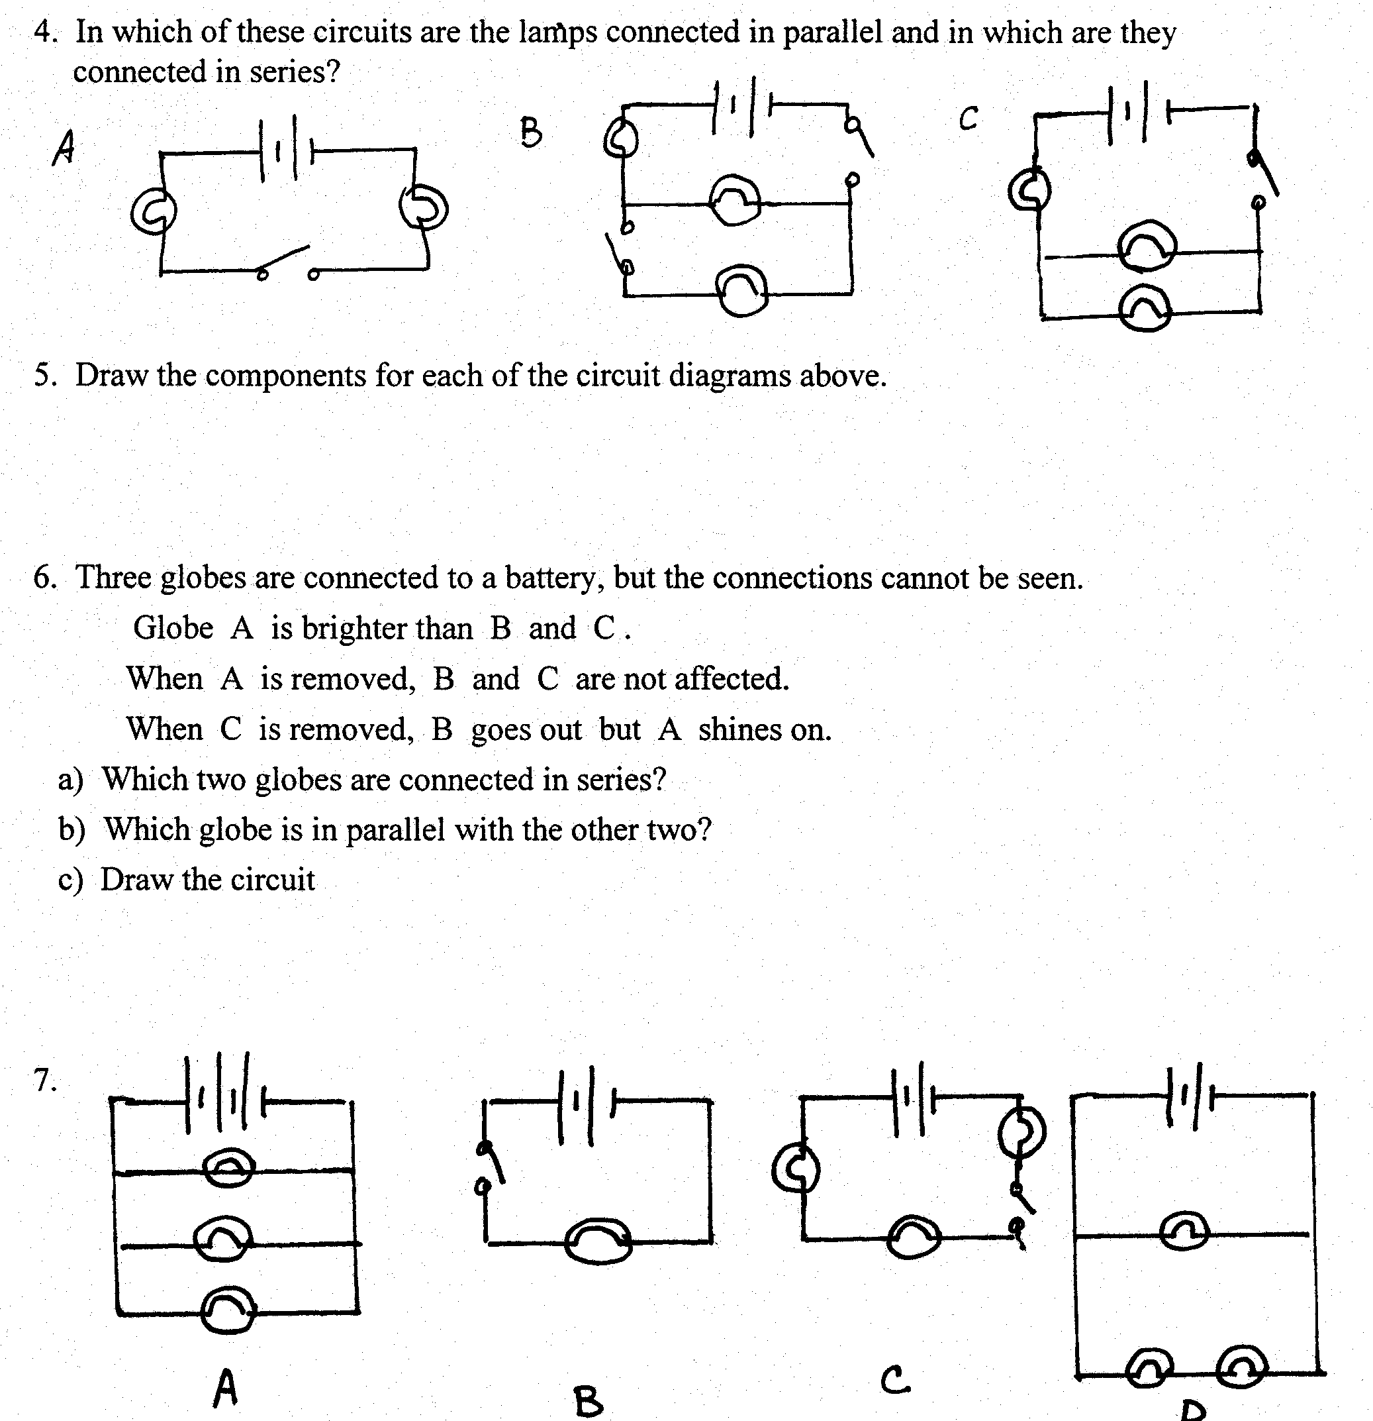

- In which circuit would the globes be the brightest? Why?

- In which circuit would the globes be the dimmest? Why?

- Write down the circuits in order of globe brightness, brightest first.

